FOSSOWAY & DISTRICT COMMUNITY COUNCIL – WIND FARM SURVEY REPORT 30TH JANUARY 2024

To help the Fossoway District Community Council represent you, we conducted a survey to know what you think about the proposed wind farm developments in Fossoway District
PROPOSED WIND FARMS

- Brunt Hill (E-Power) is located approximately 5km north-west of Kinross. The current proposal is eighteen turbines with a maximum blade tip height of 200m will generate up to 130MW of energy with 65MW of battery storage. For more details see E-Power’s website at: https://brunthillinfo.co.uk/
- Craighead Farm (Galileo) is located approximately 6km north-west of Carnbo. The current proposal is eight turbines with a maximum blade tip height of 200m and will generate up to 48MW of energy. For more details see Galileo’s website at: https://craigheadwindfarm.co.uk/
SURVEY

The survey was distributed to all 939 occupied households in the Fossoway District by volunteers. Residents could either complete the survey online or by paper copy and drop them in locations across the district. The survey was open from the 1st to the 30^{th of} November 2023. The Community Council committed to producing a report of all responses and share the results with the community at a public meeting which was held in Carnbo Village on the 30^{th of} January 2024
RESULTS
We received a total of 110 responses, 22 were handwritten and 88 online. This represents 11.7% of the Community

- Were you already aware of the current wind farm proposals at Brunt Hill and Craighead?

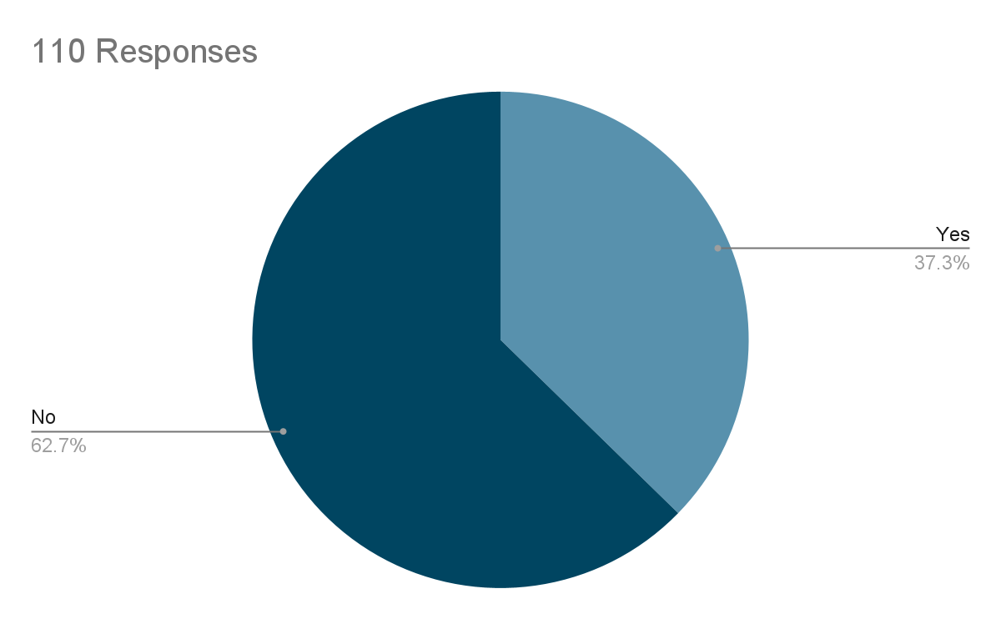

- Have you attended any of the engagement events and if so, which ones?

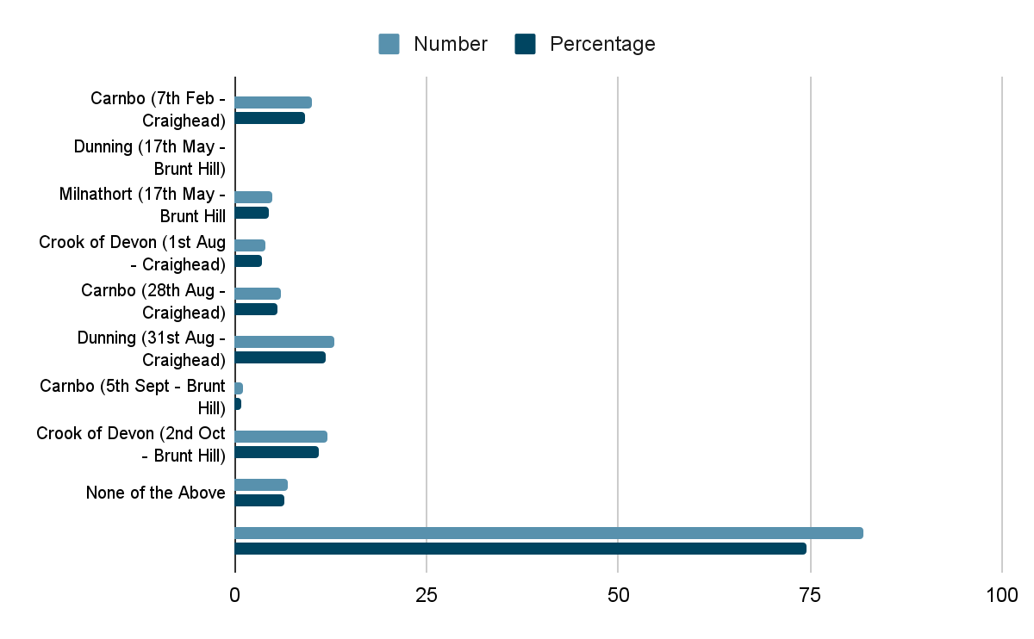

- Do you generally support renewable energy (i.e., energy generated by wind, wave, sun, or ground/air heat source)?

 | Number of Responses | % of Total
Strongly Support | 62 | 56.4
Support | 36 | 32.7
Undecided | 5 | 4.5
Oppose | 2 | 1.8
Strongly Oppose | 5 | 4.5
Total | 110
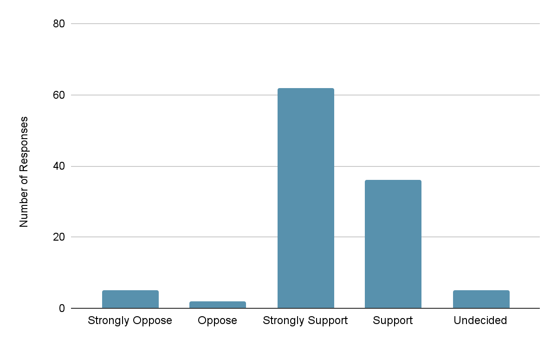

- Do you generally support onshore wind farms?
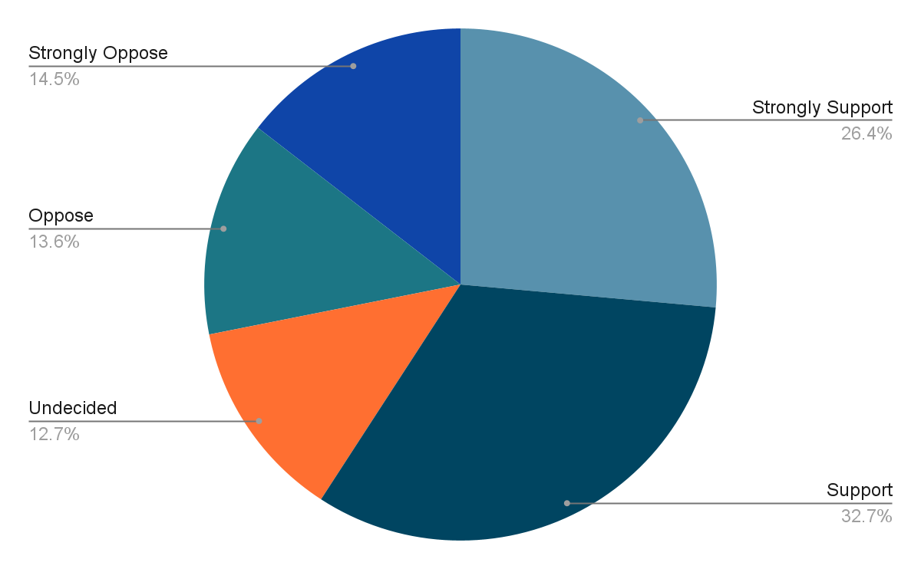

- Do you specifically support the wind farm proposals in the Ochils?
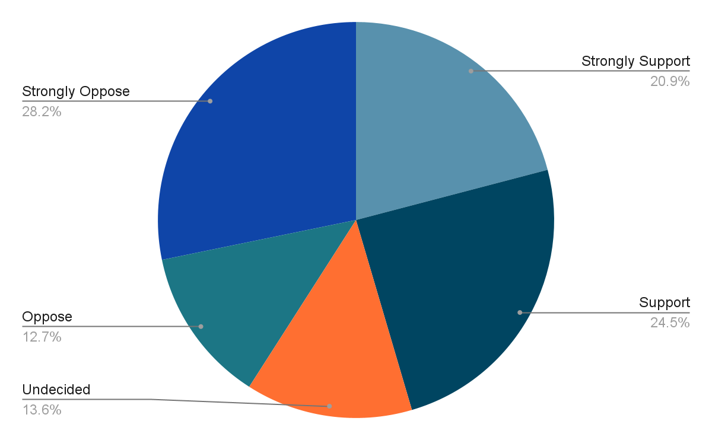

- Why do you hold this view?
Summary Blairingone - 17 Responses
There were a lot of commonalities in residents' views on the proposed location of wind farms in the Ochils. Those opposing them are concerned about the detrimental effect on the landscape citing the Scottish Government's strategy on promoting tourism and that this would have an adverse effect on it. It was also pointed out that nuclear energy is a green alternative which should be considered. Concern was also raised that it appears as though on some windy days the current turbines are not in use even in Winter months when it is assumed energy is required.
Those residents who support wind farms in the Ochils primarily have a concern about climate change and believe that wind farms are a good form of renewable energy. These residents feel less impacted by the turbines on the landscape, and one commented on them being a form of art. Interestingly there was also a comment that this form of renewable energy is preferable to nuclear.
Summary Carnbo - 14 Responses
Residents of Carnbo who oppose wind farms in the Ochils also raised a concern that the Ochils would become a wind farm landscape and that these newer turbines of 200m height would also require night lights which would be even more intrusive. The adverse impact on fauna and flora was also raised and the Developers assessment of this and mitigation steps will be of great interest. It was noted that the area sits within the Loch Leven catchment area and construction materials may contaminate our waterways. In addition, it is reported that this area contains peat which if disturbed would release carbon. Concern was also raised on where company profits would be going as the Developers appear to be from outside of the UK
Those that support wind farms in the Ochils see a requirement for renewable energy although they would ask the Developers to really consider shorter turbines to have less impact on the landscape.
Summary Crook of Devon - 35 Responses
Residents of the Crook of Devon that oppose wind farms in the Ochils raised the same concerns as residents of other settlements. In addition, several residents stated that wind farms were not as efficient or green as claimed and that there are several days when there is either not enough wind or too much wind when the turbines do not operate requiring alternative energy sources. They also raised the point that the wind farms will require linkage to the national grid which is likely to require new unsightly pylons. Residents strongly oppose the fact that NPF4 policy is supportive of wind farms although PKC current policy is not and had previously objected to plans for a wind farm in one of the Ochil locations. An alternative strategy proposed was a policy supporting local residential energy sources such as solar panels and better home insulation reducing the requirement for energy from the National Grid.
For those that support wind farms in the Ochils the main justification is the climate emergency and the requirement to rapidly move away from fossil fuels and that this outweighs concerns regarding impact on landscape.
Summary Drum - 11 Responses
Residents of Drum that oppose wind farms in the Ochils like other settlements are concerned about the adverse impact on the landscape and the Ochils habitat. Those that support wind farms in the Ochils strongly believe that the climate emergency necessitates onshore wind farms, and this includes the Ochils.

Summary Powmill - 18 Responses
Like other settlements residents of Powmill that oppose wind farms in the Ochils do not believe they are an efficient form of renewable energy and will be a blot of the landscape having a detrimental impact on the habitat. There is also a distrust of Developers as those that built the current wind farms in the Ochils promise they would not be visible from Powmill, but they are. A concern was also raised on what happens to the turbines at the end of their life span - are they recyclable? This was also raised by other settlements.
Residents that support wind farms in the Ochils believe that there is a moral duty to slow down climate change and renewable energy in the form of onshore wind farms is key to this in the UK.
Summary Rumbling Bridge - 5 Responses
In Rumbling Bridge there was only a single comment opposing wind farms in the Ochils and this was that they are an eyesore and not efficient. Those in support of them again state that this form of renewable energy will reduce CO2 emissions and be a future source of clean energy although undecided residents did note that the technology is currently underdeveloped and more efficient and better designed turbines could be available in the future.
Summary Elsewhere in Fossoway District - 5 Responses
Comments from residents living elsewhere in Fossoway District were in general undecided and whilst recognising the need for renewable energy were not convinced that wind farms in the Ochils was the best option. They raised the question on whether or not hydro power from the Glen Devon dams would be a better alternative. Those that did either oppose or support wind farms in the Ochils raised the same points as other settlements.

- Which community do you live closest to?

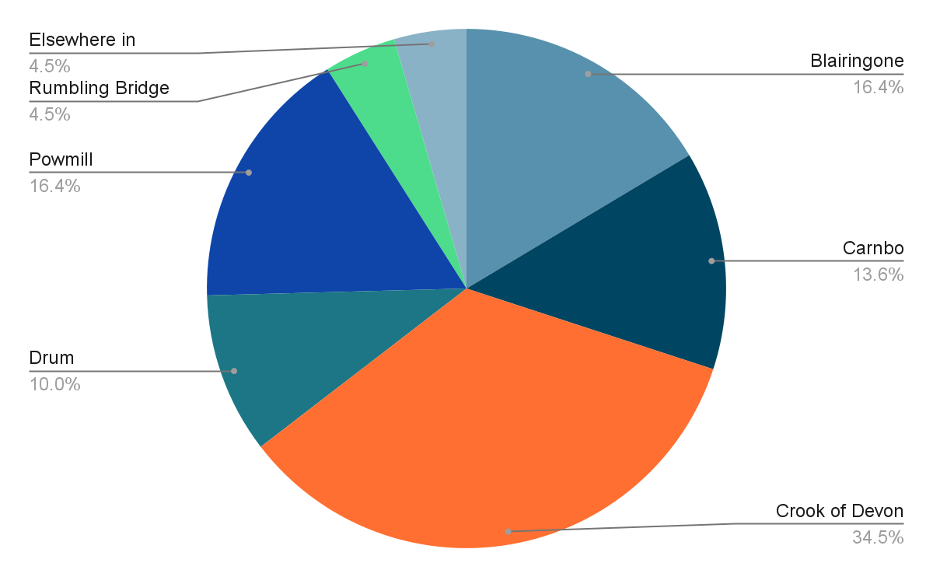

- Tell us about your views of these proposals in the construction phase.
Summary Blairingone - 15 Responses
Irrespective of whether residents oppose or support wind farms in the Ochils they all raised the same concerns regarding the construction phase and that is the additional HGVs on our local roads, many of which are narrow and some single track. The disruption to local communities is a concern although it is recognised that this will be over a defined period, and it is hoped that developers would work with the local community to minimise disruption.
Summary Carnbo - 13 Responses
As Carnbo will be the most impacted community during the construction phase then as expected there were a large number of detailed comments. The primary concern is the current lack of information on the construction routes from the M90 via the A91 to the proposed sites. Walkers heavily use local roads, and many are narrow with no pavements. Also, the tonnes of materials required for the construction of new access roads could have an even greater impact on the environment than the turbines themselves and this must be considered in any planning decision; especially the requirement for a properly constructed SUDs. It will be essential that there is careful planning and management of traffic to limit disruption to the local community.
Summary Crook of Devon - 28 Responses
Residents of the Crook of Devon are concerned about the additional HGV traffic through Carnbo and raised the same concerns as Carnbo. In addition, they are concerned about the disruption to the local area when the wind farms are dismantled at the end of their lifetime and seek assurances that this will also be carefully managed and that there will be continued local stakeholder engagement.

Summary Drum - 9 Responses
Residents of Drum raised similar concerns regarding traffic concerns and local impact in addition they also raised concern of the environmental impact of temporary construction buildings and quarrying for construction materials; especially on local wildlife
Summary Powmill - 16 Responses
Like other settlements Powmill is primarily concerned about the impact of large HGVs on the rural Carnbo community. They are seeking assurances that roads will be kept clean, and potholes routinely repaired.
Summary Rumbling Bridge - 5 Responses
Residents of Rumbling Bridge, whether opposed or supportive of wind farms in the Ochils are concerned about local disruption due to the large number of HGVs and the speed of these vehicles; although acknowledged that this will be for a defined period.
Summary from Elsewhere in Fossoway - 4 Responses
A resident from elsewhere in Fossoway has sought an analysis of the amount of CO2 produced in the construction phase and how this is offset in the future from the clean energy created from the wind farm. They also proposed that wherever possible local materials were used to restrict CO2 from transportation and that this should be prioritised over cost. It was also noted that the technology should be improved to give a life span of at least 100yrs. The resident noted that we still have operational lighthouses that are over 200 yrs. old, and they are in extremely harsh environments.
- Tell us about your views in the operational phase.
Summary Blairingone. - 14 Responses
Those that oppose wind farms are sceptical about any reduction in energy costs being seen locally. Whilst supporters see the benefit of clean energy.

Summary Carnbo - 13 Responses
Residents in Carnbo will be most affected if the wind farms are constructed and during the operational phase they are concerned about noise and light pollution. In addition, the uncertainty of the route of access roads and their use once construction has finished could impact the quiet rural community. Those that oppose the wind farms are concerned about the impact on house prices as they purchased their home in a quiet rural community with beautiful views of the Ochils. Others want to ensure that the Ochils and wind farms are accessible to walkers. Local residents are seeking an assurance that at the end of the lifetime the environment is restored, and biodiversity enhanced.

Summary Crook of Devon - 26 Responses
Residents of the Crook of Devon who oppose wind farms raised the same concerns as Carnbo. In particular they raised the concern of the number of birds that could be killed by the blades. Residents are also seeking a type of Bond to commit Developers to sympathetically dismantling turbines at the end of their Life. Those that are supportive asked that Developers enhance the biodiversity by planting native trees on lower slopes and footpaths.

Summary Drum - 9 Responses
Like other settlements residents of Drum are concerned about the visual, light and noise pollution during the operational phase and the impact on wildlife. They are also seeking assurances that access to the area will be maintained for walkers. Supporters look forward to a green source of energy.
Summary Powmill - 16 Responses
Residents of Powmill have the same concerns as other settlements. In addition, supporters of the wind farms want to ensure there is continual engagement with Developers during the operational phase to ensure biodiversity enhancement plans are fully met.

Summary Rumbling Bridge - 5 Responses
Residents that support wind farms propose that in time the turbines will be a nice addition to the landscape whilst opposers view them as an eyesore

Summary Elsewhere in Fossoway - 4 Responses
Residents elsewhere in Fossoway that oppose wind farms believe they will adversely impact the landscape.

- If these proposals go ahead, there will be a community windfall; how would you like to see that money spent?
Summary Across All Settlements - 100 Responses
The responses from Residents to the questions on how any community benefit fund should be spent were largely consistent with few geography specific views.
Village Halls & Community Spaces
As a District we have Village Halls in Carnbo, Crook of Devon and Powmill which are run by volunteers. There was a consensus that funds should go to the existing Halls in support of greener energy solutions and decarbonising our community assets including the Fossoway Primary School. Funds should also be used to enhance our Community Spaces.
Blairingone School
The Fossoway Community Development Trust is in the process of seeking funds for a feasibility study on the financial sustainability of the Trust leasing or purchasing the Blairingone School. Residents of Blairingone would like funds used to support this.
Bridge over River Devon
Several residents suggested that funds be used to replace the bridge over the river Devon that was washed away.
Local Housing
It was suggested that grants should be made available to local residents to support decarbonising of homes. These could be in the form of matched funding and/or means tested. In addition, funds could be used to support development of affordable housing for local young people.
Facilities for Local Residents
Several residents requested that improvement in playgrounds and youth facilities be funded along with a request for much needed local childcare groups. Facilities should also be improved for elderly in our community with a focus on improving health and wellbeing. The latter is a key component of the Business case for the community asset transfer of the former Blairingone School.
Several of our rural settlements have no shops and very limited or non-existent access to everyday services such as post office, bank etc. Funds should be prioritised for enabling visiting shops and services to all of our rural communities. In addition, funding to support a reliable public transport system aligned to that of Glenfarg should be prioritised.
Roads, Cycle Paths and Footpaths
There were a large number of residents who supported the funding of improving our cycle and footpaths, including improved signage and way finders. There were several residents who supported spending some of the funds on improving traffic calming measures on the A977 and A91 and improving the maintenance of our roads and footpaths. The view was that this has been adversely impacted by Perth and Kinross Council budget cuts. Conversely many residents sought an assurance that the funds would not be used to cover Perth and Kinross Council budget shortfalls leading to a reduced service. This is likely to always be controversial.
Energy
Many residents supported a scheme that provided a discount to local residents on their energy bills which could be based on closeness to the wind farms. Some believe that such a scheme would not be workable and therefore if the wind farms do go ahead more details of any schemes would be essential.
The provision of non-profit EV charging points in each of our communities was a funding suggestion.
Investment
A resident suggested that some of the funds could be invested in Government 30-year Bonds providing the community with an income. Lastly it was suggested that there must be a simple funding application process to ensure that the many local volunteer-based organisations can easily access the funds.

